**Assignment – 13, 14, 15**

Course: SC-374

Computational and Numerical Methods

Instructor: Prof. Arnab Kumar

Made by:

Yatin Patel – 201601454

Rutvik Kothari – 201601417

**SET - 13**

**Numerical stability and implicit methods**

**Problem - 1**

♦ **Statement:**

The initial-value problem $Y’(x) = LY(x), Y(0)=1 , x>0$, can be numerically sloved by euler’s method according to $yn={\left(1+Lh\right)}^{n}$.Test the stability of this method at the fixed value of $x=0.2$ for $h=0.1,0.05,0.01,0.001.L=-100.$ Carry out similar with the backward euler method.

$$Y(0.2) = 2.0612e-09$$

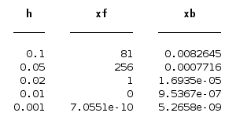

**SET - 14**

**Trapezoidal method**

**Problem - 1**

♦ **Statement:**

Consider the following initial value problems, Numerically solve both by Euler’s method and trapezoidal method, for range $0<=x<=6$, separately using $h = 0.2,0.1,0.05$. For each problem, plot the numerical solutions for every value of h along with the analytical solution. Compare the graphs for errors.

(A) $Y’\left(x\right)=-Y(x) , Y(0)=1.$

(a) Graph of function for $h=0.2 , h=0.1 and h=0.05$

(1) for $h=0.2$

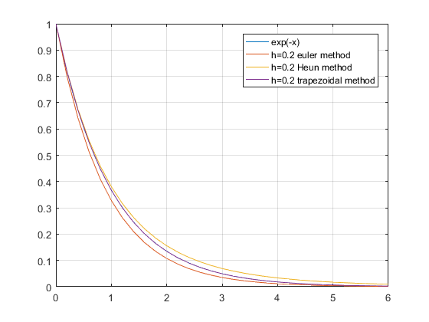

(2) for $h=0.1$

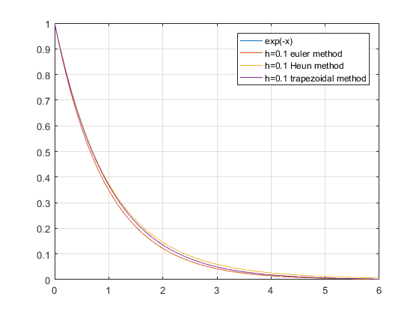

(3) for $h=0.05$

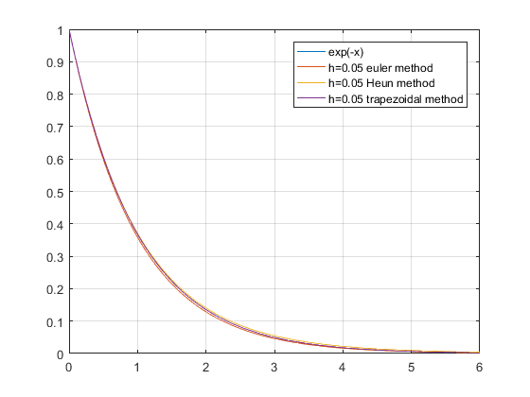

(b) Error function for $h=0.2, h=0.1 and h=0.05$

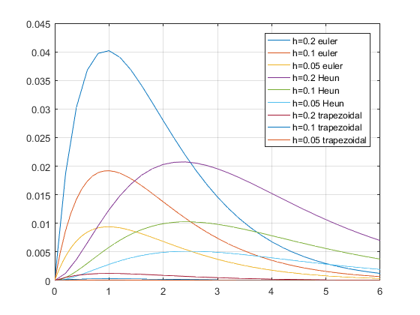

(B) $Y’\left(x\right)=\frac{\left(Y\left(x\right)+ x^{2} –2 \right)}{\left(x+1\right) }, Y(0)=2$.

(a) Graph of function for $h=0.2, h=0.1 and h=0.05$

(1) for $h=0.2$

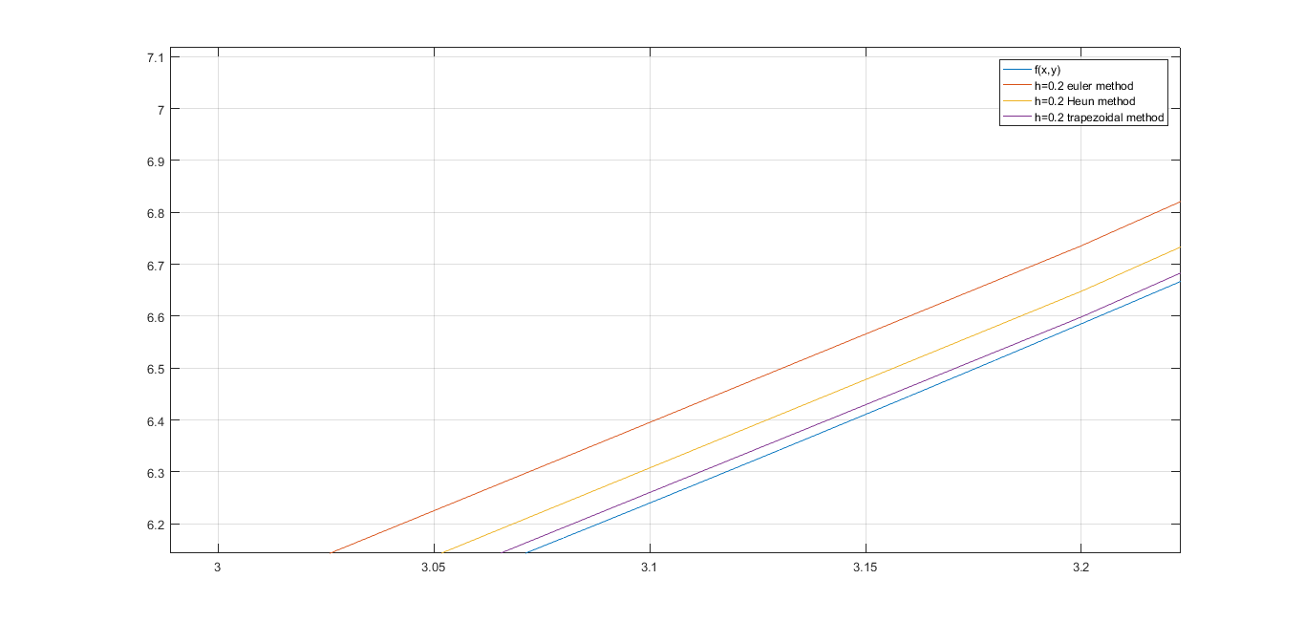

(2) for $h=0.1$

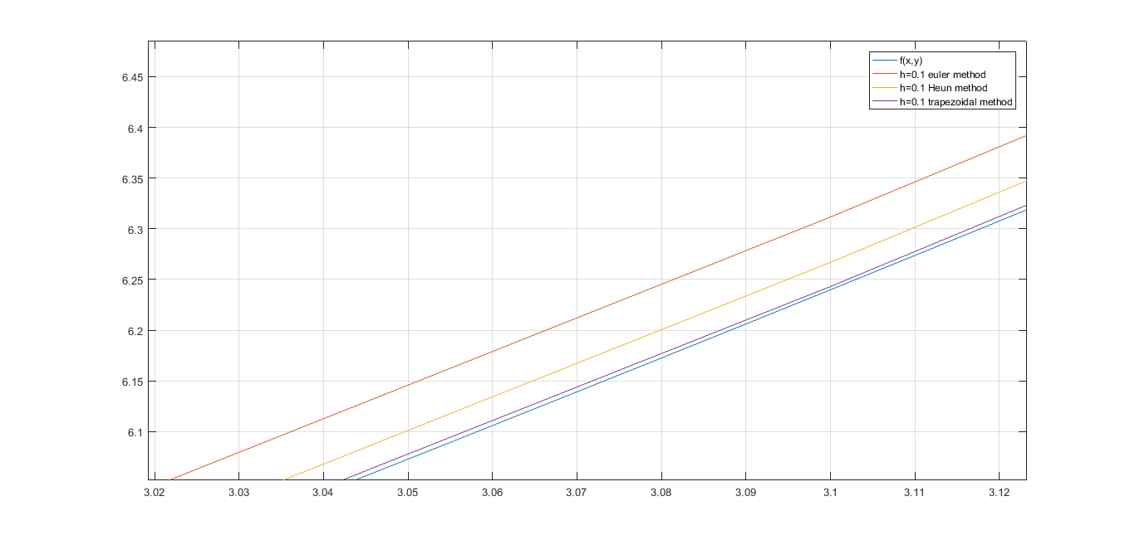

(3) for $h=0.05$

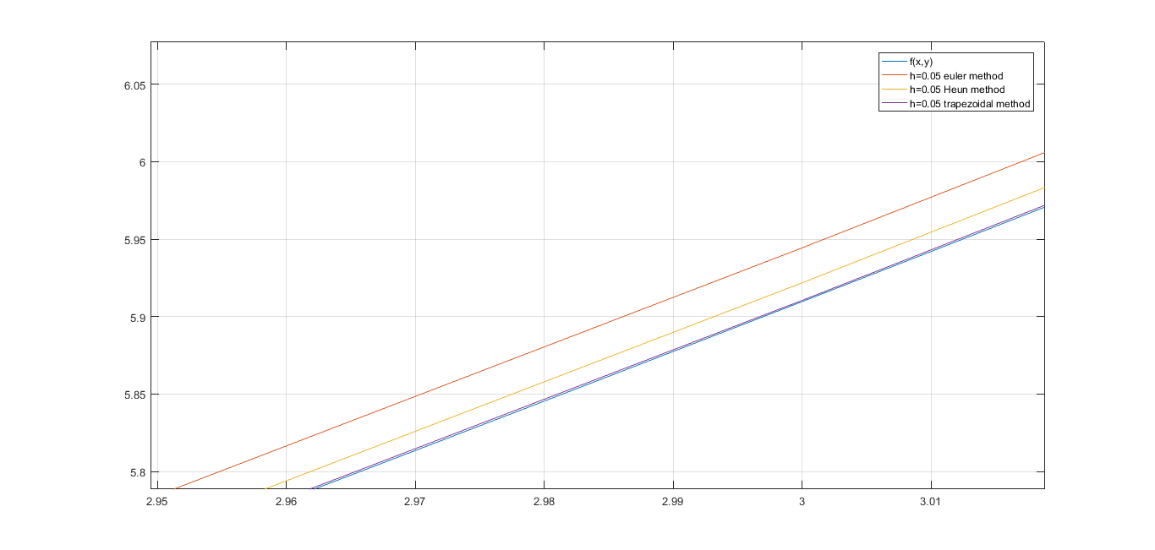

(b) Error function for $h=0.2, h=0.1 and h=0.05$

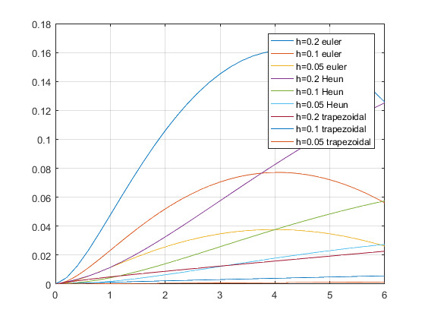

**SET - 15**

**Taylor’s method**

**Problem - 1**

♦ **Statement:**

On the initial-value problem, $’(x) = -Y(x)+2cosx , Y(0)=1$, apply both the first order and second order taylor method for $0<=x<=10$. Use $h=0.1,0.05$. Plot the results of both methods along with the exact integral solutions for comparison.

(a) Graph of function for $h=0.1 and h=0.05$ both first-order and second-order

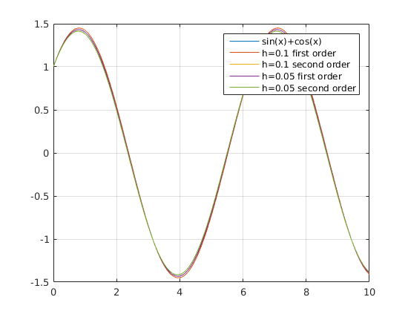

(b) Graph of error function for $h=0.1 and h=0.05$ both first-order and second-order

